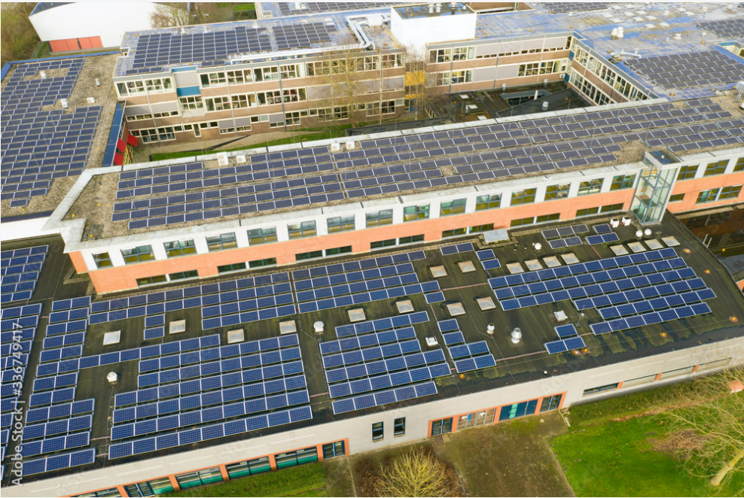

APPLICATION FORM

NORTH EAST AND YORKSHIRE NET ZERO HUB

SCHOOL SOLAR enabling fund

- PROJECT OVERVIEW

  - Applicant name:

  - Applicant organisation:
[Include registered address, legal status, whether incorporated and company number if you have one]

  - Organisation structure:
[Describe the type and structure of your organisation and how it is governed. Who has ultimate control of your organisation (directors, trustees, shareholders, members, etc) and how are decisions made?]

  - Applicant contact details:
[These contact details will be used in line with GDPR. We would also like to keep you up to date with new funding announcements, events and news. Please let us know if you are happy to receive this type of communication by email].

 | Main contact | Alternative contact
Name
Position in organisation
Address

Tel
Email
Check the box to receive emails from the Ney Net Zero Hub about funding announcements, news and events. | ☐ | ☐

  - Project Location:
[Specify location, including, where possible, postcode]

  - Project Summary:
[Provide a succinct summary of what you intend to do and what it will deliver (100-200 words).]

  - Key personnel:
[Identify the people who will be responsible for delivering the project and ensuring that the project meets its objectives].

Name | Project Role | Role in organisation | Contact details

  - Total project value and identified funding sources:
[Add additional rows as necessary]

Funding source | Funding type (e.g. grant, loan?) | Amount (£) | Agreed?

  - Previous funding awards
[Identify any public funding awards received by your organisation within the past 3 years]
Reference no (if applicable) | Name of project | Name of grant/award scheme | Date grant received | Grant value (£)

  - Value of grant funding being requested from the Hub.
[Identify how much you would like to apply for from the Hub. Minimum funding request is £5,000, maximum request is £10,000.]
£

  - Project outputs and outcomes:
[Identify the outputs of your project and provide a description of these outcomes. Please add additional rows if necessary.]
Output/outcome | When Achieved by? | Description/Details
Installed Solar PV Panels
Completed ancillary works to enable the installation of solar PV panels

- PROJECT NEED

  - Project development:
[Describe the activities undertaken to get the project to this stage; e.g. option selection, feasibility, detailed design, procurement, full business case etc. Add additional rows as necessary]
Project development stages completed to date
Task | Description | When achieved

  - Need for intervention:
[identify why Hub funding is needed – e.g. a clear funding gap, specific market failure, need to reduce externalities.]

Please include your report/assessment along with any other evidence (such as Board minutes confirming viability gap) with your application.

- VALUE FOR MONEY

  - Options assessment:
[Outline alternative options that have been considered, the likely result and whether they may be viable. Add additional rows as necessary]

 | Option | Likely result | Viable/not viable
1
2
3
4
5
6

  - Preferred option:
[Describe how/why the Preferred Option has been selected. What benefits does it bring over and above other options? What assumptions have been made in calculating benefits?]

  - Project Costs:
[Please include links to quotes/estimates or attach these to your application. Add extra lines as necessary. Please only include costs that are relevant to the funds you will receive from the Hub, do not include the costs associated with buying and installing the solar panels]

Item / Activity | Cost (£) | Quote/Estimate Reference

- PROJECT MANAGEMENT

  - Project Milestones
[Identify key milestones].

Milestone | Start Date | End Date | Notes

  - Permissions and Consents
[Provide detail of any applicable consents, permissions or contractual arrangements. Add extra lines as needed]

Activity | Notes
Land and building ownership/tenure
Planning permission
Environmental permits
Key conditions associated with consents, permissions of contractual arrangements

  - Assessment and mitigation of risks:
[Please include a risk assessment here or attach to your application]

Declaration and Data protection
By submitting and/or agreeing to the submission of this grant application you agree to the following declaration:

I confirm that, to the best of my knowledge and belief, all of the information is true and correct and I accept full responsibility for it. I understand that, should this application be successful, I will be required to supply additional information. If there is any change to the information I have provided, I will notify the NEY Net Zero Hub without delay.

I understand that any information I supply may be used by public bodies or their appointed agents in connection with the funding and that I may be contacted in relation to the application, from time to time, whether or not my application has been successful.

I am aware of the conditions that apply to this grant application and have complied with them. I declare that I have read, understood, and complied with all the relevant guidance. I understand that my organisation may be inspected, and I agree to give access, cooperate, and provide such assistance as is required.

I understand that acceptance of this application form does not in any way signify that Tees Valley Combined Authority has agreed to invest. I declare I am an authorised signatory of the lead organisation, with the authority to sign off this application form and have notified the necessary senior finance officers.

Important Information

You should not commence project activity, or enter into legal contracts, including the ordering or purchasing of any services before your application has been formally approved and you have entered in a grant funding agreement. Any expenditure incurred before the approval date is at your own risk and may render the project ineligible for support. If you know and recklessly make a false statement to obtain grant aid for yourself or anyone else you risk prosecution, the recovery of all grant payments, additional financial penalty and exclusion from other schemes operated by Tees Valley Combined Authority. By submitting this form, you are confirming that you have read and agree the above declarations and you consent to us processing the information we collect from you in accordance with our privacy Policy.

Privacy Policy

Your information will be stored and processed in accordance with the data protection Act 2018 (DPA). Tees Valley Combined Authority is the data controller for personal data you give to us/we hold about you. Tees Valley Combined Authority process your data in accordance with their Privacy Policy which can be found here. We use it in line with the Data protection Act. We are subject to the Freedom of Information Act 2000 and other obligations under law which require us to act transparently, and which grant certain rights of access to the public information held by us. This means, that although we respect the sensitivity of the information, there may be legal requirements which oblige us to disclose tis information.

We will use the information you supply to administer, process, and assess your grant application. Information may be shared with other persons or organisations helping us with the assessment and monitoring of applications. Information you provide will also be shared with Government Departments and the wider North East & Yorkshire Net Zero Hub. Your information may also be shared with Government departments and other public bodies for the purpose of fraud prevention. The application and evaluation may also be subject to audit and review by internal and external auditors who may need to access the information you submit in your application.

If you supply information related to third parties as part of your application, you must ensure that you inform those third parties about how you use this information and inform them that this information has been passed onto Tees Valley Combined Authority.

We will not hold your information for longer than is necessary. We will hold most of your information for three years after project closure unless we have a legitimate reason to keep it for longer.

If any information we hold changes or is incomplete, please tell us and we will amend it.

Approval Signatures

Authorised Signatory for Organisation
Printed Name
Signature
Position in Organisation
Date
☐ I confirm that our organisation (including any directors or partner or any other person who has powers of representation, decision or control) has not been convicted of conspiracy, corruption, bribery, fraud, money laundering or drug trafficking, and has not been declared bankrupt.

By signing this page, you are confirming that the information provided in this application form is accurate and that you meet the eligibility criteria for the funding. You are also confirming that you agree with the Data Protection information provided above.

