Open Call for New Board Members
An opportunity to help drive the regional net zero agenda for the North East and Yorkshire as a member of the North East & Yorkshire (NEY) Net Zero Hub Board
The NEY Net Zero Hub is a partnership organisation that works with public sector organisations, their stakeholders and communities to develop fundable net zero projects and deliver local energy strategy. We exist to accelerate the region’s ambitious efforts to drive a low carbon, clean growth future.
We have an exciting opportunity to add 4-5 new advisory member roles to the governance Board of the NEY Net Zero Hub who will contribute their varied expertise and experience to support direction setting, decision making and scrutiny of Hub delivery.
This is an open opportunity for us to augment existing experience and we encourage applications from diverse backgrounds and sectors. We would be interested in a range of expertise that might include but is not limited to:
- Technical specialisms in fields covered by the Hub’s Strategic Priorities
- Experience of commercial investment and/or green finance
- Understanding of public health issues in relation to fuel poverty, energy security and technology anxiety
- Representation of communities and other end users
- Research and innovation in fields covered by the Hub’s Strategic Priorities
Applying to be an advisory Board member is an opportunity for you to bring your valuable experience and knowledge of the region’s net zero community to help us shape the direction of Hub delivery and promote the acceleration of net zero throughout the North East & Yorkshire.
Please review the attached information which provides an overview of the Board Member role, along with terms of reference and the Hub’s Strategic Priorities.
If you and would like to become one of our advisory Board members, please complete the attached Expression of Interest which should be submitted by 18/08/23.
Membership will be approved by a panel drawn from the current Board membership which will include Chair Chris Rowell, representative from Department for Energy Security and Net Zero and be supported by the Hub Manager. Candidates may be invited to attend an informal interview ahead of selection.
All decisions will be made by 15/09/23.

Annex 1 – Advisory Board Member Role

Structure
The Board of the NEY Net Zero Hub comprises representation from the Hub’s six partners as regional decision makers and strategic (non-decision making) representation from key stakeholders who attend as observers. Board business is supported by the injection of technical knowledge, experience and expertise from within the region through a number of advisory roles.
The structure of the Board and relationships with the Hub Manager and funder are set out below:

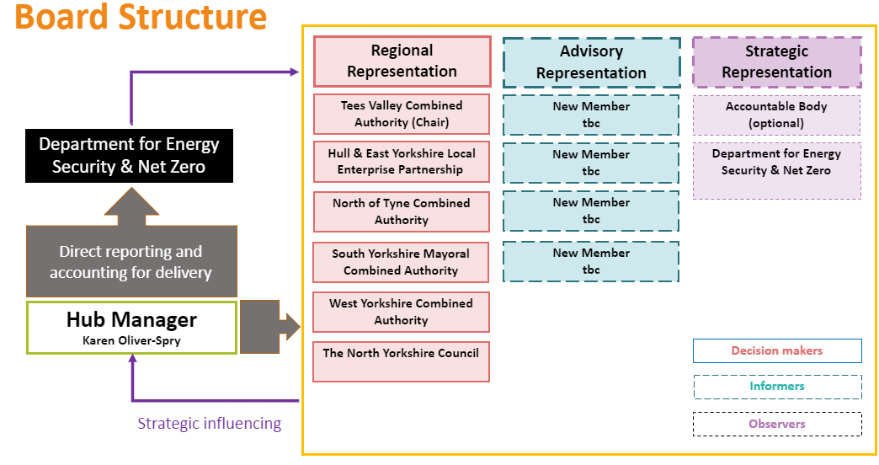

Role and Responsibilities
The Board works collectively and with the Hub executive to deliver the Government’s Net Zero Hub Agenda.
All regional and advisory Board members are responsible for supporting and promoting effective Hub delivery in the following ways:

Board Role​ | Activities​
Scrutiny​ | Provide constructive challenge, advocate for Hub impact, verify financial probity, monitor risk and support officers to identify mitigating actions ​
Assurance​ | Agree projects and programmes, inform the allocation of Hub resource/funding, mediate and facilitate Hub delivery​
Oversight​ | Promote and advocate Hub activity, review applications and appraisals, provide officers with advice and guidance​ to support delivery
Collaboration​ | Develop collaborative project ideas, support the exchange of knowledge and information across the region, represent the Hub on networks and forums, direct Hub policy/strategy ​

In addition to the above, regional representatives of the Hub’s partner Combined Authorities or LEPs take decisions on the allocation of funding and resource.

Requirements
Advisory Board members must live and/or work within the Hub region and not be an employee of one of our partner Combined Authorities or LEPs.
You will need to commit to attending regular meetings, reviewing papers circulated in advance. Board meetings take place every 2 months and are held in the afternoon business hours of the 2nd Tuesday of the month. These may be convened online or in person.
In addition to the regular meeting schedule, two in-person ‘Away Days’ are convened each year for the Board and Hub Team.
Any known or potential conflict of interest should be declared at application. Pecuniary or non-pecuniary interests must be registered and/or declared at the relevant point in the meeting agenda.
The role is not remunerated but reasonable travel expenses for attending in person meetings will be reimbursed.

Annex 2 – NEY Net Zero Hub Board Terms of Reference

PURPOSE

To oversee delivery and progress of the NEY Net Zero Hub’s activities, setting strategic priorities and making decisions that drive forward net zero strategy and accelerate the delivery of net zero projects at a local level.

To review and discuss the development and progress of the pipeline of local energy/net zero projects to ensure Hub resources are being used effectively, in line with the HUB’s MOU with The Department and regional strategies.

OBJECTIVES

- To develop and agree strategic priorities to inform Hub activity.
- To receive reports and monitor progress of Hub delivery against The Department requirements and agreed KPIs.
- To review risks, issues and exceptions and determine appropriate course of action based on recommendations.
- To maintain communications across participating organisations and The Department.
- To select projects to receive allocated Hub support (financial or capacity), prioritise resources and make funding decisions in alignment with agreed governance processes.
- To monitor performance, spend and outcomes of programme delivery, providing constructive challenge where necessary and support to overcome barriers.
- To work collaboratively to develop solutions for Hub-wide issues.
- To participate in bi-yearly meetings with The Department.

MEMBERSHIP

The MOU with The Department requires that The Hub Board will be made up of appropriate regional representatives from the Hub’s constituent LEPs or Combined Authorities, as well as other stakeholders such as regional leaders and third parties to ensure full and balanced geographical coverage.

Each Hub member organisation’s senior management can nominate one representative to be a member of the Hub Board who must be appropriately qualified and experienced in the view of other members and must be an executive officer of the organisation.

Deputies are permitted but must have an equivalent level of qualification and experience. Hub-funded officers cannot deputise for Board members.

The Board will identify and agree additional stakeholder roles within the Board to provide adequate regional representation to meet the requirements of The Department and support the Hub Executive with recruitment or invitation to these roles.

Additional attendees may be permitted by agreement of the Hub Board Chair or nominated deputy.
Board roles will be honorary and not remunerated.

The Board will be supported and advised by the NEY Net Zero Hub executive, representatives of the accountable body and independent experts as needed.

CHAIR

The Chair will be the nominee of TVCA unless a deputy is appointed. If the Chair is not able to be present at a board meeting then the remaining members will appoint a deputy for the duration of the meeting.

QUORUM

The quorum for meetings shall be four Board members or their nominated qualified deputies. If a Party does not attend a meeting, does not field a deputy and does not respond to papers circulated for the meeting they shall be deemed to have waived their influence for any decisions taken in their absence.

CONDUCT

- The Board will operate in a business-like, non-bureaucratic fashion.
- A schedule of meetings (at least every 2 months) will be prepared on an annual basis.
- Board members will conduct themselves according to the Nolan Principles of public life.
- Board members with personal, commercial or financial interests in any agenda items will declare them at the relevant points on the agenda and not participate in discussion or votes on those items.
- Board members with declared personal, commercial or financial interests in any agenda items may be required to leave the room at the discretion of the Chair for the duration of the agenda item discussion.
- In the Chair’s absence, a vote will be held to choose a chair for the meeting.
- Where a vote is required, this will be through a simple majority with a casting vote for the Chair.
- Board meetings are confined to Board members and advisers except for external presenters and observers which have been agreed with the Chair in advance.
- There will be a formal record of notes and decisions taken.

REPORTING ARRANGEMENTS

Papers will be prepared by the Hub executive, collated and circulated at least 3 working days in advance of the meeting.

FREQUENCY AND LOCATION OF MEETINGS

The Board shall meet at least every two months. Urgent decisions required from the Board may be taken by electronic communication in between meetings, with the same requirements for quorum and declarations of interest as above.

Board meetings will usually be held on MS Teams but may be held in person by agreement.

Board members will also participate in up to two Away Days each year to support strategic planning and direction setting.

Annex 3 – Hub Strategic Priorities

