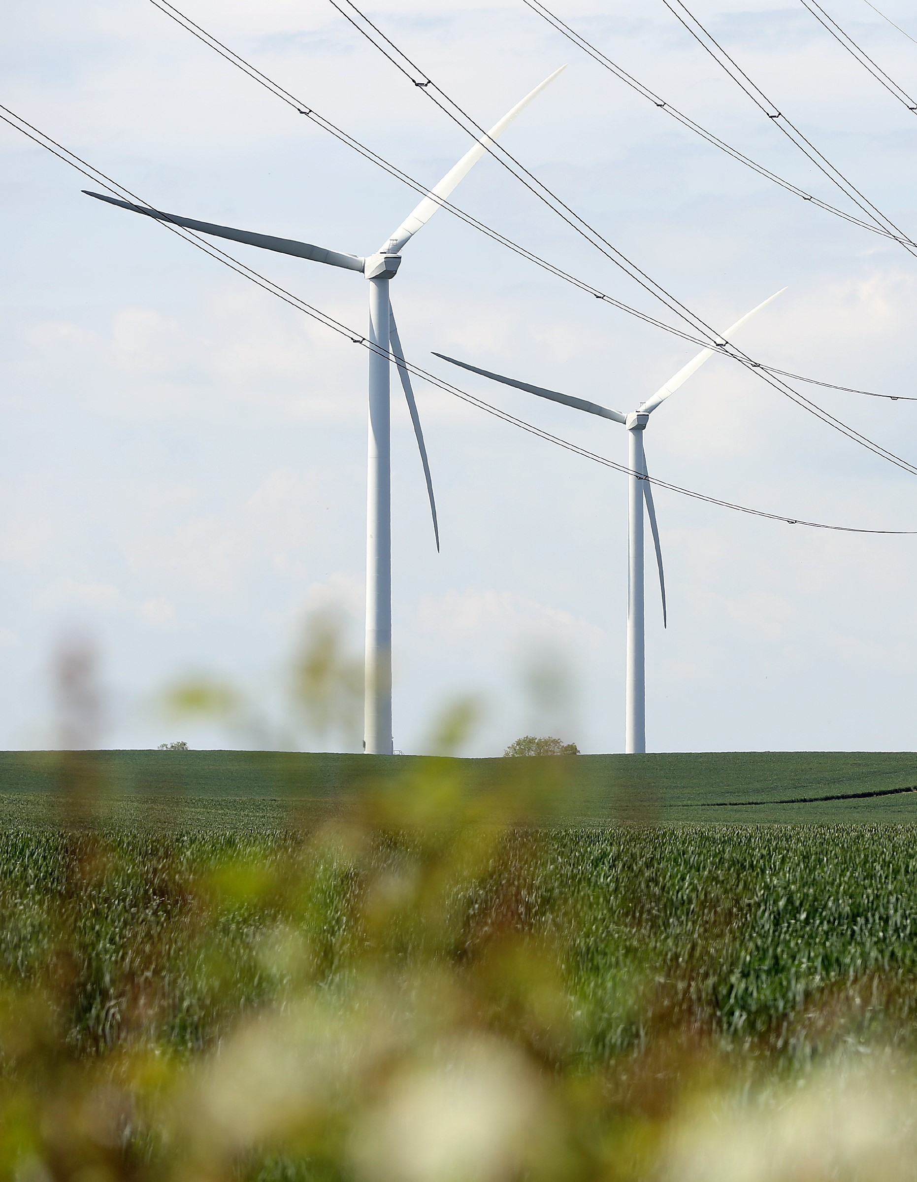
Subidy


APPLICATION FORM FOR TECHNICAL ASSISTANCE FOR COMMUNITY ENERGY – ENERGY AUDITS

TECHNICAL ASSISTANCE FOR COMMUNITY ENERGY – ENERGY AUDITS

PRE-APPLICATION CHECKLIST
Please ensure that you have completed all actions on the pre-application checklist before you submit your application.
Action:
Application signed and Declaration agreed
Ensured project falls within NEY Hub geography
All application questions answered
Ensure all information provided is correct at the time of application submission
Ensure all supporting documents are provided as per the below table

SUPPORTING DOCUMENTS CHECKLIST
Please ensure that you have compiled and attached all supporting documents before you submit your application.
Supporting Document:
Evidence that permission for an energy audit has been confirmed by the building/site owner if this is not the applicant.
Evidence of match funding (match funding of 20% of estimated energy audit cost).

  - Project name:

  - Applicant organisation:
[Include registered address, and type of organisation (i.e. community energy group or Local Authority working in partnership with a community energy group), status, whether incorporated and company number if you have one]

  - Organisation structure:
[Describe the type and structure of your organisation and how it is governed. Who has ultimate control of your organisation (directors, trustees, shareholders, members, etc) and how are decisions made?]

  - Applicant’s contact details:
[These contact details will be used in line with GDPR. We would also like to keep you up to date with new funding announcements, events and news. Please let us know if you are happy to receive this type of communication by email].
 | Main contact | Alternative contact
Name
Position in organisation
Address

Tel
Email
Check the box to receive emails from the Ney Net Zero Hub about funding announcements, news and events. | ☐ | ☐

  - Delivery partners:
[if you are a Local Authority working in partnership with a community energy group, or vice versa, please provide details of the partner organisation]
Partner organisation
Name of organisation
Type of organisation
Address

Name of contact within organisation
Tel
Email

  - If you are applying as a community energy group and are not formally partnering with your Local Authority on this project, please confirm that they are nevertheless aware of the project:
Please confirm that you have contacted your relevant Local Authority about your project before submitting your application.

  - Name and address of building/site to receive energy audit:
[Specify location, including, where possible, postcode]

  - Type of building to receive energy audit, including who owns it
[note that permission to conduct an energy audit will be required as supporting evidence if the applicant does not own the building]

  - Why has this building/site been selected and what are your aims and ambitions for it in relation to a community energy project?
[max 250 words]

  - How will your aims and ambitions set out above (9) in relation to the selected building/site contribute to local energy security and/or local energy planning?
[max 250 words]

  - Why is an energy audit required and how do you intend to use it to achieve your goal?
[max 250 words]

  - What do you anticipate being the additional phases of your project and how do you intend to fund these?
[max 250 words]

  - What other sources of funding have been explored to commission an energy audit and why is Hub funding required?
[max 200 words]

  - Previous funding awards
[Identify any public funding awards received by your organisation within the past 3 years; these might include funding received through the Energy Projects Enabling Fund and/or the Rural Community Energy Fund]
Reference no (if applicable) | Name of project | Name of grant/award scheme | Date grant received | Grant value (£)

15. Identified match funding source
[You must provide match funding of 20% of the estimated cost of an energy audit, i.e. £400 - £800.]
Funding source | Funding type (e.g. grant, loan?) | Amount (£) | Agreed?

Declaration and Data protection
By submitting and/or agreeing to the submission of this grant application you agree to the following declaration:
I confirm that, to the best of my knowledge and belief, all of the information is true and correct, and I accept full responsibility for it. I understand that, should this application be successful, I will be required to supply additional information. If there is any change to the information I have provided, I will notify the NEY Net Zero Hub without delay.
I understand that any information I supply may be used by public bodies or their appointed agents in connection with the funding and that I may be contacted in relation to the application, from time to time, whether or not my application has been successful.
I am aware of the conditions that apply to this application and have complied with them. I declare that I have read, understood, and complied with all the relevant guidance. I understand that my organisation may be inspected, and I agree to give access, cooperate, and provide such assistance as is required.
I understand that acceptance of this application form does not in any way signify that Tees Valley Combined Authority has agreed to invest. I declare I am an authorised signatory of the lead organisation, with the authority to sign off this application form and have notified the necessary senior finance officers.

Privacy Policy
Your information will be stored and processed in accordance with the data protection Act 2018 (DPA). Tees Valley Combined Authority is the data controller for personal data you give to us/we hold about you. Tees Valley Combined Authority process your data in accordance with their Privacy Policy which can be found here. We use it in line with the Data protection Act. We are subject to the Freedom of Information Act 2000 and other obligations under law which require us to act transparently, and which grant certain rights of access to the public information held by us. This means, that although we respect the sensitivity of the information, there may be legal requirements which oblige us to disclose this information.
We will use the information you supply to administer, process, and assess your application. Information may be shared with other persons or organisations helping us with the assessment and monitoring of applications. Information you provide will also be shared with Government Departments and the wider North East & Yorkshire Net Zero Hub. Your information may also be shared with Government departments and other public bodies for the purpose of fraud prevention. The application and evaluation may also be subject to audit and review by internal and external auditors who may need to access the information you submit in your application.
If you supply information related to third parties as part of your application, you must ensure that you inform those third parties about how you use this information and inform them that this information has been passed onto Tees Valley Combined Authority.
We will not hold your information for longer than is necessary. We will hold most of your information for three years after project closure unless we have a legitimate reason to keep it for longer.
If any information we hold changes or is incomplete, please tell us and we will amend it.

Approval Signatures

Authorised Signatory for Organisation
Printed Name
Signature
Position in Organisation
Date
☐ I confirm that our organisation (including any directors or partner or any other person who has powers of representation, decision or control) has not been convicted of conspiracy, corruption, bribery, fraud, money laundering or drug trafficking, and has not been declared bankrupt.

By signing this page, you are confirming that the information provided in this application form is accurate and that you meet the eligibility criteria for the funding. You are also confirming that you agree with the Data Protection information provided above.

All documentation is published on the NEY Net Zero Hub’s website: Community Energy Support - North East & Yorkshire Net Zero Hub (neynetzerohub.com)
All completed application forms and supporting documentation must be sent to enquiries@NEYnetzerohub.com.
Any queries regarding the support or the application process can also be directed to enquiries@NEYnetzerohub.com.
All applications must be received by midnight on 02/06/2024.

